Discussion Question: 100 Things
Using the 100 Things Every Designer Should Know About People reading assignment, select two (2) of the "things" you read about. In your post, include the number and title of the "thing" (i.e. #36 Time is Relative) and then do two embellishments, one embellishment and one visual example, or two visual examples.
- Embellish: Tell us something that the reading did not tell us on that specific "thing" or embellish on what was presented. Be sure you are adding meaningful content to the conversation and not just making noise. Your addition can be a link to an article or you can write out your embellishment.
- Visual Example: Provide us with a graphic example that is relevant to web design. This can be something you create or something you find. Again, be sure to add meaningful content to the conversation.

After reading the assigned topics for our final module, I decided to focus on Topic #93: People Think Choice Equals Control. When there are choices for users, they feel they are in a position of power and in control of their autonomy, even though this is not true. In 2022, Tanner Kohler, on the Nielsen Norman Group website, discusses ways to increase user autonomy through UI design. Adding personal customization options throughout the user interface, emphasizing key information with headings and formatting, and the ability to roam and go in a flexible order all help give users more autonomy (Kohler, 2022).
I included a picture of the appearance setting on Mac. This makes users feel more in control of their device and can make it more representative of their preferences. 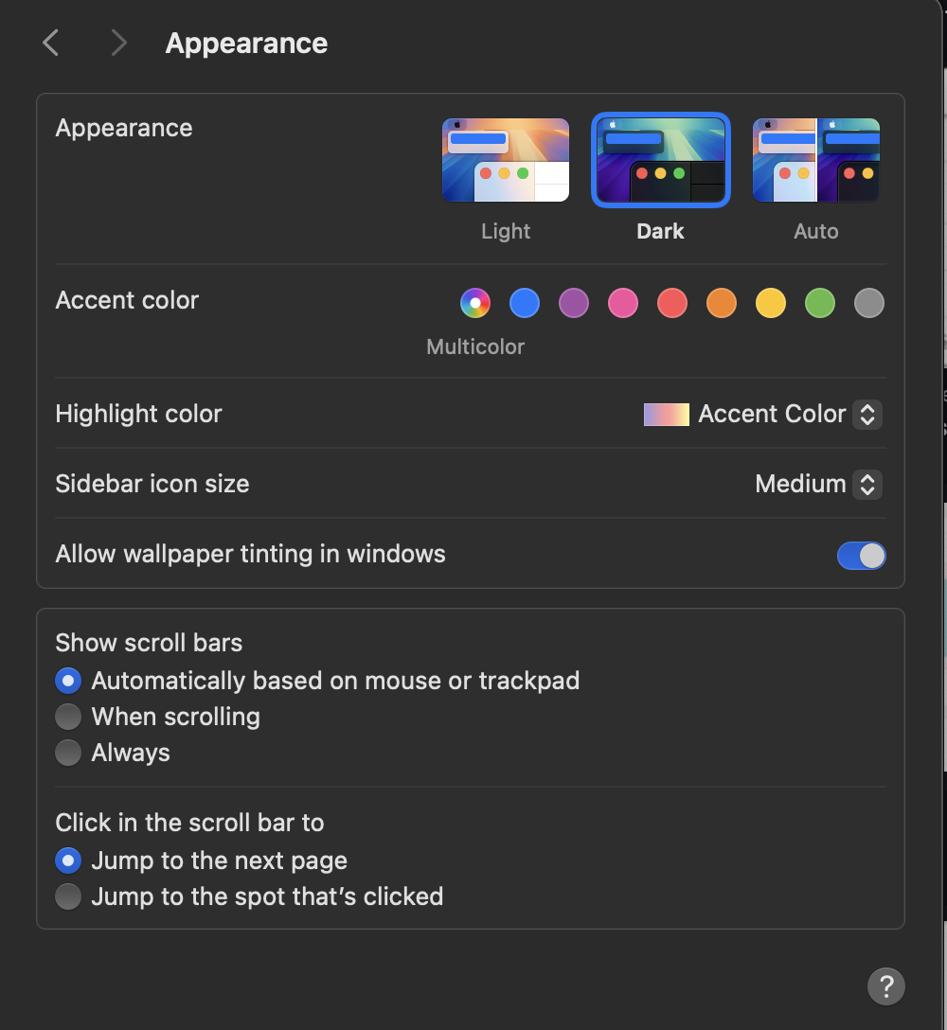

The second topic of embellishment is for Topic #98: When People Are Uncertain, They Let Others Decide What To Do. Whether conscious of this or not, other people greatly influence us. This can even be so if we do not know them and they are not famous. So, appealing to this basic human trait can be beneficial in making an impact and increasing the odds that a user will buy a product or service. In his 2023 article, Demir Tutnich discusses how web designers can influence people’s thinking. The layout and design of a website for program can help mold a positive impression for users, which would help with “perceptions of the product or service” (Demir Tutnich, 2023).
https://medium.com/design-bootcamp/how-designers-can-influence-peoples-thinking-aa4cbbae1a91
I included a screenshot of the FAQ page on Etsy. Since people look to others when uncertain, already having help forums and places for users to ask questions and receive answers can help users decide what to do and how to resolve their issues.
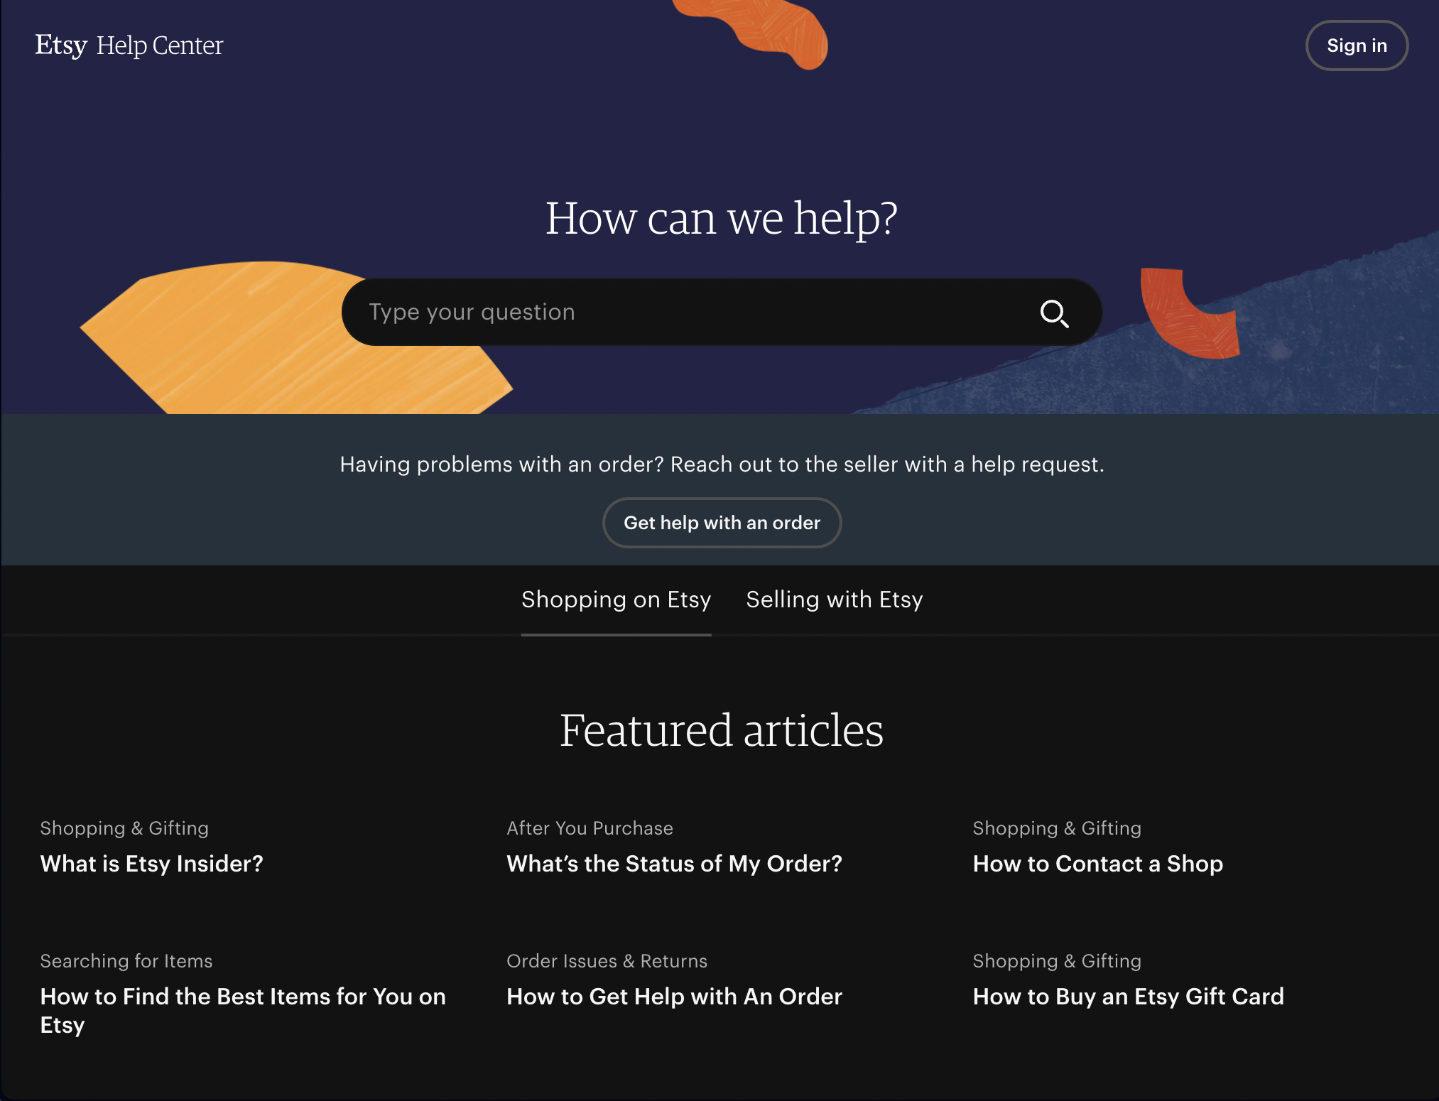

References
Demir Tutnich. (2023, April 11). How designers can influence people’s thinking❓ - Bootcamp - Medium. Medium; Bootcamp. https://medium.com/design-bootcamp/how-designers-can-influence-peoples-thinking-aa4cbbae1a91
Kohler, T. (2022, April 17). Three Methods to Increase User Autonomy in UX Design. Nielsen Norman Group. https://www.nngroup.com/articles/increase-user-autonomy/

Before you submit your thread, put your name in the subject line.

Assignment Requirements and Grading:
- An initial post of approximately 250 words is due by Thursday, 11:59 p.m., CST.
- For the initial post to be considered substantive, it should be at least 250 words in length and fully cover the topics being presented. Single sentence definitions or responses will not be awarded points.
- Submit your post by clicking on the Assignment Link above, then Create Thread. You must create a thread in order to view your peers' posts. Tip: Create your post in a word document and then copy and paste your work into the thread.
- A minimum of three (3) responses, to the original threads of other students, of 100-200 words each are due by Sunday, 11:59 p.m., CST.
- To view the rubric grading criteria, click on the following link: Discussion Board Grading Rubric.
(50 points)

